**Remote Desktop**

Remote desktop allows a user to view the desktop of another user remotely over the network and access it as if it is her own desktop.

Steps for connectivity:

**Step 1: Creating a hot-spot connection**

1.1 Create new Wi-Fi network on any one of the device

1.2 Set the security parameters.

1.3 Ask the other user to connect to the network

**Slave**

**Master**

PC 2(Slave) allows access to master

PC 2 must allow other devices the permission to view it

PC 1(Master) accesses PC 2

Master requires slave’s IP address and password (if any) for remote access

**Step 2: Slave allowing access to master**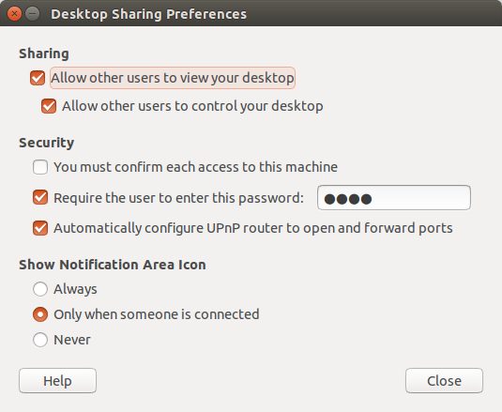

2.1 Open desktop sharing.

2.2 Check the first option if unchecked

2.3 Set a password (optional)

2.4 Use ifconfig command on terminal and share

the inet address (The one under wlan0) with the master

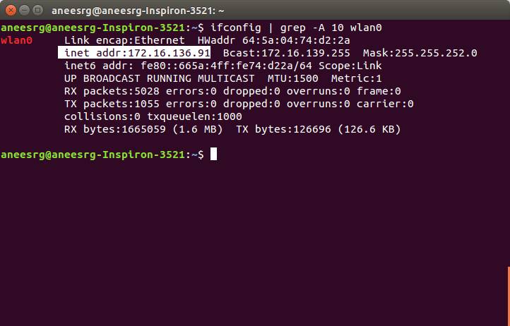

**Step 3: Master accessing slave**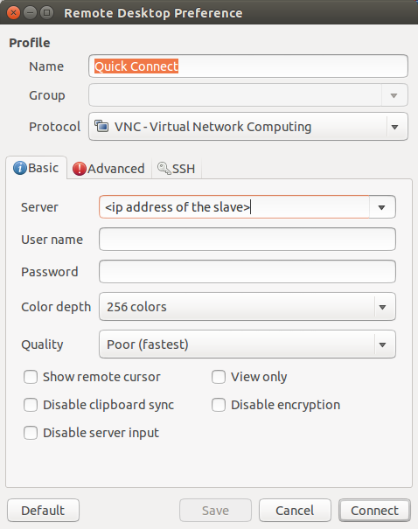

3.1 Open Remmina Remote Desktop.

3.2 Create a new connection.

3.3 Set connection protocol as VNC from the drop down list.

3.4 Enter the IP address of the slave.

3.5 Connect to the PC(Enter the password if any).